Frequency response calculations for Actimate Mini crossover low pass section, assuming constant resistive impedance of the driver of 5.3Ω.
>> C1=8.2E-6;
>> R1=1;
>> L1=0.85E-3;
>> Zs=5.3;
>> num=[5.3*C1*R1 5.3];
>> den=[Zs*L1*C1+C1*R1*L1 Zs*C1*R1+L1+0.3*C1*R1+Zs*0.3*C1 Zs+0.3];
>> freqs(num,den)

Same for high-pass section, with tweeter impedance of 4.3Ω
>> C1=6E-6;
>> C2=12E-6;
>> L1=0.13E-3;
>> num1=[4.3*L1*C1*C2 3.87*C1*C2 0 0];
>> den1=[6.5*C1*C2*L1 C2*L1+C1*L1+5.85*C1*C1 7.4*C2+0.9*C1 0];
>> freqs(num1,den1)
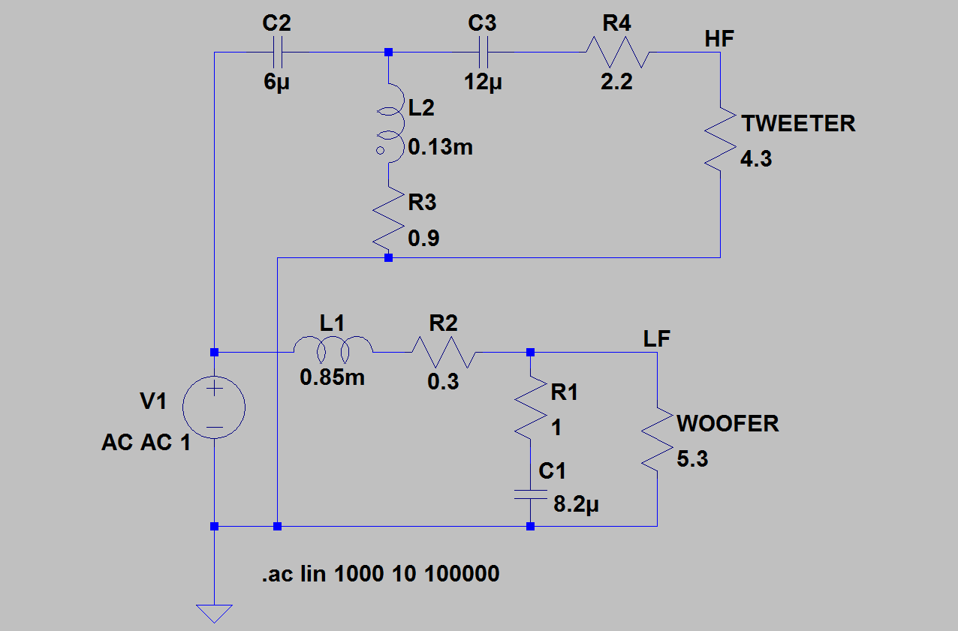
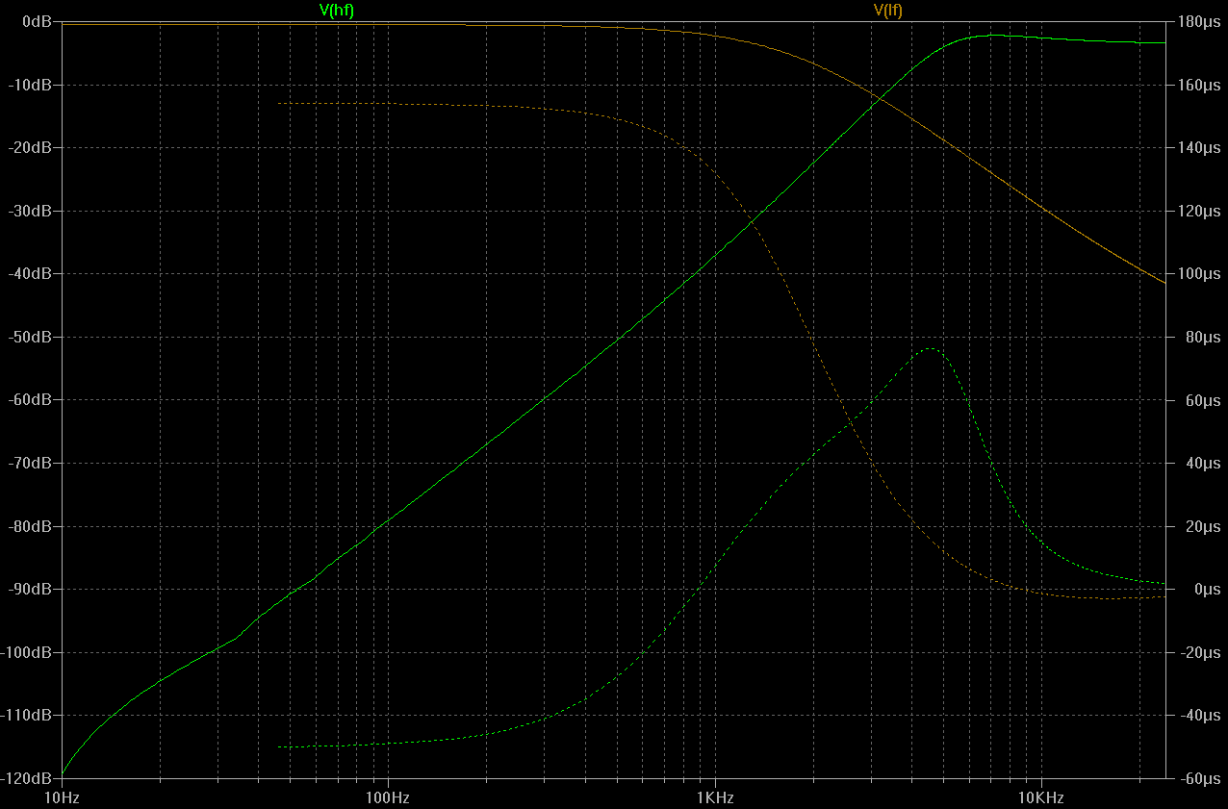

Size returns number of rows first, then columns, like in example:
>> a=[ 2 3; 3 4 ;5 6]
a =
2 3
3 4
5 6
>> size(a)
ans =

3 2

Converting filters to digital form using bilinear transform yields:
ys =

0.0190 0.4420
Column on the left is the low pass filter; on the right is high-pass filter
0.0518 -0.3662
0.0731 -0.1986
0.0836 -0.0391
0.0866 0.0500
0.0847 0.0696
0.0797 0.0494
0.0728 0.0195
0.0650 -0.0023
0.0571 -0.0113
0.0493 -0.0107
0.0421 -0.0059
0.0355 -0.0013
0.0296 0.0014
0.0245 0.0020
0.0200 0.0015
0.0162 0.0006
0.0131 -0.0001
0.0104 -0.0003
0.0082 -0.0003
0.0064 -0.0002
0.0049 -0.0000
0.0038 0.0000
0.0029 0.0001
0.0021 0.0000
0.0016 0
0.0011 0
0.0008 0
0.0005 0
0.0003 0
0.0002 0
0.0001 0
0.0000 0
0 0
-0.0000 0
-0.0001 0
-0.0001 0
-0.0001 0
-0.0001 0
-0.0001 0
-0.0001 0
-0.0001 0
-0.0000 0
-0.0000 0
-0.0000 0
Speaker cross-over schematic
TOP position (both switches) = active cross-over
BOTTOM – build-in passive cross-over

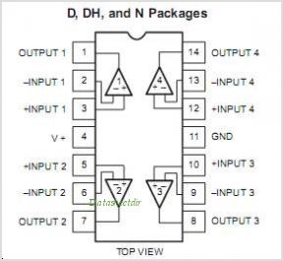

Microphone recording checklist
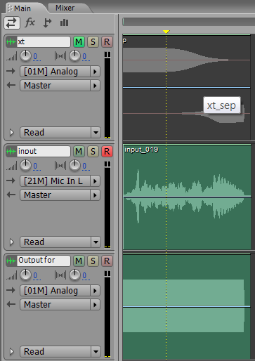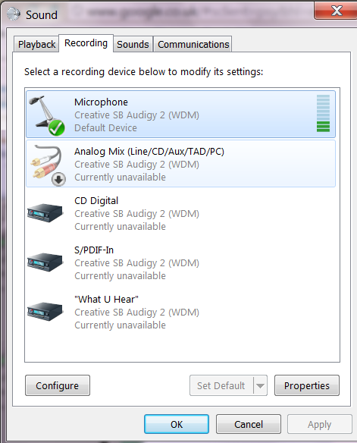
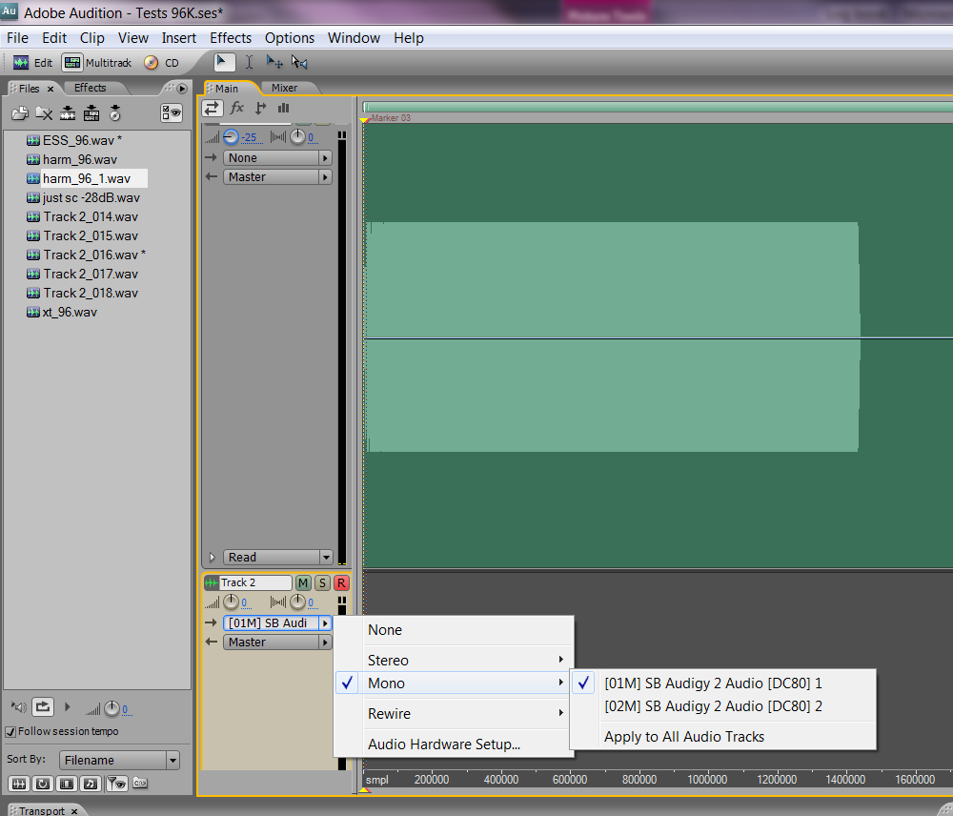
For ASIO4ALL drivers, its important that [DC80] 1 input is selected, otherwise cross-talk signal will be recorded.

- Mic phantom power ON
- Op-amp amplifier configured in differential mode with gain 10
- Op-amp board ON
- Microphone as default device
Try loopback (one of the channels directly to mic input) if no sound
Try connections
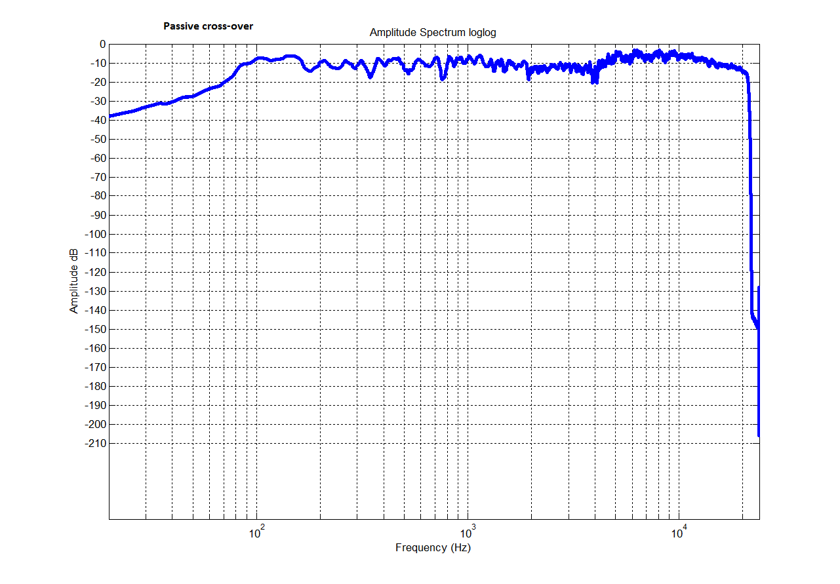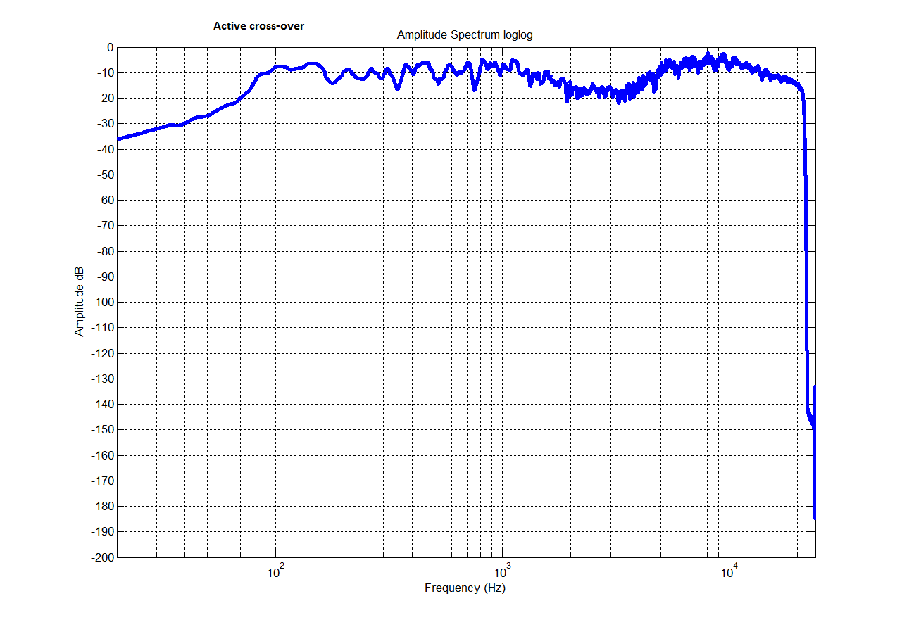

Room dimensions and modes:
Width 2.77m
Length 4.68m
Height 2.93m
Frequency Hz | Mode | 180.1 | Tangential
36.8 | Axial | 184 | Axial
58.8 | Axial | 186.3 | Oblique
62.2 | Axial | 186.5 | Axial
69.3 | Tangential | 187 | Tangential
72.2 | Tangential | 188.4 | Tangential
73.6 | Axial | 190.1 | Tangential
85.6 | Tangential | 190.6 | Oblique
93.1 | Oblique | 191.1 | Tangential
94.2 | Tangential | 192.7 | Tangential
96.3 | Tangential | 193.1 | Tangential
110.4 | Axial | 194.2 | Tangential
112.9 | Oblique | 195.6 | Tangential
117.6 | Axial | 198.4 | Oblique
123.2 | Tangential | 199 | Oblique
124.3 | Axial | 200.5 | Tangential
125.1 | Tangential | 200.9 | Oblique
126.7 | Tangential | 201.4 | Oblique
129.7 | Tangential | 202.9 | Oblique
133 | Tangential | 203.6 | Oblique
137.5 | Tangential | 208 | Tangential
138 | Oblique | 208.9 | Oblique
138.7 | Tangential | 215.8 | Tangential
139.7 | Oblique | 216.7 | Tangential
142.4 | Oblique | 217.1 | Oblique
144.5 | Tangential | 218.3 | Tangential
147.2 | Axial | 218.9 | Oblique
152 | Oblique | 220.5 | Tangential
156 | Oblique | 220.8 | Axial
158.5 | Tangential | 222.1 | Tangential
159.8 | Tangential | 223.5 | Oblique
161.3 | Tangential | 224.6 | Oblique
166.3 | Tangential | 225.7 | Oblique
170.2 | Oblique | 227 | Oblique
171.1 | Tangential | 228 | Oblique
172.8 | Oblique | 228.5 | Tangential
175 | Oblique | 229.4 | Tangential
176.3 | Axial | 229.7 | Tangential
176.4 | Oblique | 229.7 | Oblique

!!!! Note: Matlab displays normalised frequency 0...1 with respect to Niqyist frequency, Fs/2. Other sources present normalised frequency with respect to Fs with range 0...0.5

Design goals:
- Maximally flat magnitude of frequency response
- Constant group delay – equal time delay at all frequencies
Verification of frequency response measurement model
- RC high-pass pass filter
$$\frac{Vo}{Vin}=\frac{sCR}{sCR+1}$$
C=100nF, R=1KΩ

Note on setting up audio drivers for Audigy SoundBlaster 2
ASIO4ALL drivers work better than Creative’s own ASIO drivers. ASIO4ALL allows recording and playback in 96KHz mode, native drivers only allow to go up to 48KHz. Also, ASIO4ALL drivers produce much smaller, positive (as opposed to acausal delay) and predictable delay of ? samples. Here’s the best configuration:
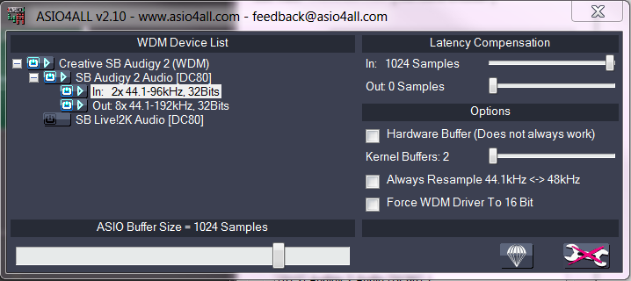
ASIO buffer size needs to be reasonable size to prevent pops and clicks from appearing on the output. In input latency compensation does not appear to make a difference. Out setting should be left at 0.

Note on phase recovery techniques
FFT deconvolution techniques basically does not work. Quadrature phase detector does work, with error increasing with frequency (predictably). Oversampling at 96KHz should improve the results.
Custom algorithm to unwrap the phase is needed. Diff and then cumsum method does not appear to work.

Figure 1 - unwrapped phase of sound card response vs. 64 samples delay

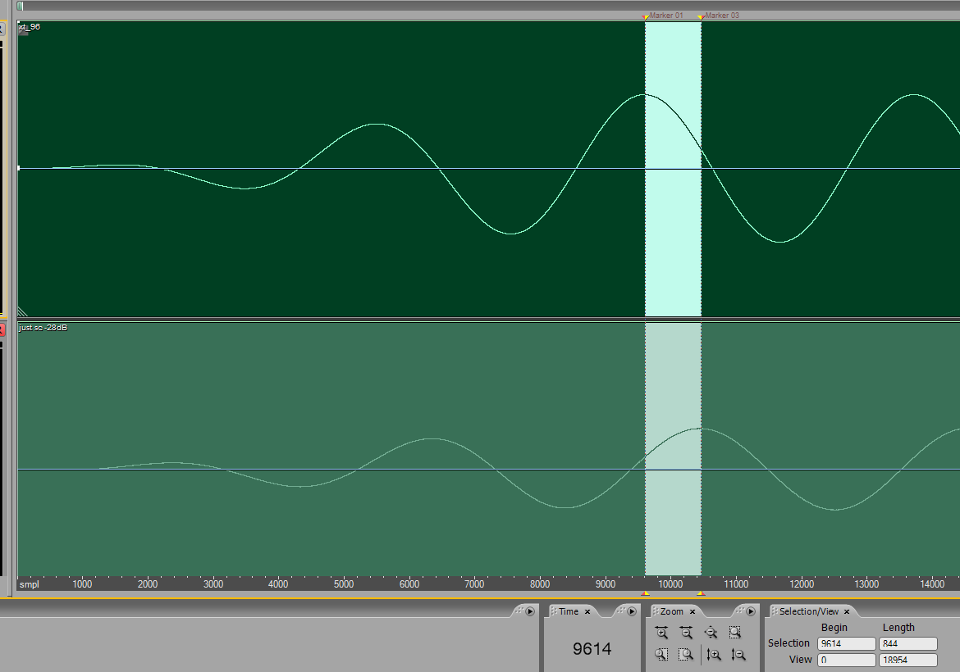

Filter files:
1 | Lp, 100nF 10K -30dB
2 | Lp, 100nF 1K -30dB
hp 1 | Hp, 100nF 1K -30dB
Xover 96 lp | -30dB, cone unobstructed
Xover 96 lp 1 | -25dB, cone help still with a hand
Shelf 96 1 | -15dB 100n || 10K +1K shelf filter

Octave stuff
One octave is double the frequency, $=f_{0}×2≈f_{0}×{10}^{0.3}$ . Octave can be sub-divided in semi-octaves as follows. Say we want to have 12 semi-octave increments. Then$f=f_{0}×{10}^{(\frac{0.3}{12}×k)}$, where k=1..12.
Swept sine stuff
$$x\left(t\right)=\sin\left(K\left(e^{\frac{t}{L}}-1\right)\right)$$
$$w\left(t\right)=\frac{d}{dt}\left(K\left(e^{\frac{t}{L}}-1\right)\right)$$
$K=\frac{T{∙w}_{1}}{ln⁡\left(\frac{w_{2}}{w_{1}}\right)}$ , $L=\frac{T}{ln⁡\left(\frac{w_{2}}{w_{1}}\right)⁡}$
$w\left(t\right)=w_{1}e^{\frac{t}{T}ln⁡⁡\left(\frac{w_{2}}{w_{1}}\right)}$ – expressing angular frequency w through t
Now express t through known f
$$e^{\frac{t}{T}ln⁡⁡\left(\frac{w_{2}}{w_{1}}\right)}=\frac{w}{w_{1}}$$
Take ln of both sides:
$$\frac{t}{T}\ln\left(\frac{w_{2}}{w_{1}}\right)=\ln\left(\frac{2πf}{w_{1}}\right)$$
$$t=\frac{\ln\left(\frac{2πf}{w_{1}}\right)∙T}{\ln\left(\frac{w_{2}}{w_{1}}\right)}$$
Working out semi-octave smoothing
$22000={22×10}^{\frac{0.3}{48}×N}$, N=?
${10}^{\frac{0.3}{48}×N}=\frac{22000}{22}=1000$, taking log of both sides
$N=\frac{48}{0.3}log⁡(1000)$, N=480

Phase response of this filter:

$$\frac{V_{o}}{V_{i}}\left(s\right)=\frac{{sC}_{1}R_{1}R_{2}+R_{2}}{{sC}_{1}R_{1}R_{2}+\left(R_{1}+R_{2}\right)}$$

Inverse sine swept filter: why should inverse filter drop off at -6dB/octave?
6dB per octave means DOUBLE the amplitude (${10}^{\frac{6}{20}}=2)$, and 4 times the power (${10}^{\frac{6}{10}}=2)$
$P=\frac{1}{T}\int_{0}^{T}{x^{2}\left(t\right)dt=}\frac{1}{T}\int_{0}^{T}{\sin^{2}{(x)}dt}$, where T is the period of the sine wave
$$P(T)=\frac{1}{2}-\frac{\sin\left(2T\right)}{4T}$$
Expressing T as 1/f, and plotting P(f) against frequency, we see that power reduces by 4 times or 6dB every octave.
This corresponds to halving of amplitude every octave.
Tw 1 | 20cm, -6dB
Tw 2 | I turned up know on the amplifier, so I had to re-take measurements to have consistent amplitudes

